# TOUCH DIMMER SWITCH CIRCUIT USING ARDUINO

**A MINIOR PROJECT REPORT**

Submitted in Partial Fulfillment of the Requirements for the Degree of

# Electronics and Communication Engineering By

**Md. Aftab (171FA05037)**

**R.V.L Karthik (171FA05329)**

**M.V. Narasimha Rao (171FA05179)**

Under the Esteemed Guidance of

# Ashish Thakur Assistant Professor



(ACCREDITED BY **NAAC** WITH **‘A’** GRADE)

# DEPARTMENT OF

**ELECTRONICS & COMMUNICATION ENGINEERING VFSTR , VADLAMUDI**

**GUNTUR-522213, ANDHRA PRADESH, INDIA**

**November 2019**

**CERTIFICATE**

This is to certify that the minor project entitled **”TOUCH DIMMER SWITCH CIRCUIT USING ARDUINO”** that is being submitted by **Md.Aftab,Sd.Yaseen,M.V.Narasimha Rao** bearing **Regd. Nos. 171FA05037, 171FA05059, 171FA05179** in partial fulfilment for the award of **III** year I semester B.Tech degree in Electronics and Communication Engineering to Vignan’s Foundation for Science Technology and Research , is a record of work carried out by him under the guidance of **Mr.Ashish Thakur** of ECE Department.

Signature of the faculty guide Signature of Head of the Department Mr.Ashish Thakur M.Tech Dr.T.Pitchaiah M.E, Ph.D MIEEE

Assistant Professor Assoc. Professor

# Abstract

A Touch Dimmer Switch Circuit is a simple project, where the dimmer action is achieved with the help of a Touch Sensor. While a regular switch is used to simply turn ON or OFF a light, a Dimmer (or Dimmer Switch) will allow us to control the brightness of the light. Without a Dimmer Switch, the light bulbs tend to glow at full brightness consuming maximum power. If full brightness is not required, then Dimmer Switches can be used and save some energy. With the help of a Dimmer Switch, we can vary the brightness from fully off to fully on.

Different light bulbs need different dimmer switches and there are different types of Dimmer Switches available in the market. Some of the commonly found Dimmer Switches are Slider type and rotary type.

In this project, we have designed a Touch Dimmer Switch using Arduino. The Touch Dimmer Switch Circuit is implemented using a Touch Sensor. The circuit design, components and working of the project is explained in the following sections.

**Table of Contents**

**Page No.**

**Chapter 1: Introduction 5**

**Chapter 2: Components Required and Description 6**

2.1. Components Required

2.2.1. Arduino UNO

2.2.2 Touch Sensor

**Chapter 3: Circuit Diagram**

**Chapter 4: Code**

**Chapter 5: Working**

**Chapter 6:Output**

**Chapter 7: Conclusion and Future Scope**

**Chapter 8: Applications References**

**CHAPTER 1**

**INTRODUCTION:**

Early dimmers were directly controlled through the manual manipulation of large dimmer panels. This required all power to come through the lighting control location, which could be inconvenient, inefficient and potentially dangerous for large or high-powered systems, such as those used for stage lightening.

The design of the Touch Dimmer Switch Circuit is very simple and is explained here. The touch sensor is given the power supply by connecting 5V to VCC and ground to GND pins. The SIG pin of the touch sensor is connected to any of the digital input / output pin of the Arduino UNO board. Here, it is connected to digital I/O pin 8.

Next, we will connect a small incandescent bulb that glows on DC. The bulb is interface with the Arduino UNO board with the help of a transistor. So, first connect the base of a transistor like 2N2222 to any digital I/O pin of Arduino UNO with the help of a current limiting resistor.

Then connect the collector terminal of the transistor to the 5V power supply. And finally, connect a bulb between the emitter and ground terminals. This completes the design of the circuit

# CHAPTER 2 COMPONENTS REQUIRED AND DESCRIPTION:

## COMPONENTS REQUIRED:

* + - Arduino UNO
    - Touch Sensor(TTP223)
    - 2N2222 NPN Transistor
    - Small Bulb
    - 1 KΩ Resistor
    - Power supply
    - Breadboard
    - Jumper Wires

## DESCRIPTION

### Arduino UNO:

The Arduino UNO is an open-source microcontroller board based on the microchip ATmega 328P microcontroller and developed by Arduino.cc. The board is equipped with sets of digital and analog input/output (I/O) pins that may be interfaced to various expansion boards (shields) and other circuits. The board has 14 Digital pins, 6 Analog pins, and programmable with the Arduino IDE (Integrated Development Environment) via a type B USB cable. It can be powered by the USB cable or by an external 9-volt battery, though it accepts voltages between 7 and 20 volts. It is also similar to the Arduino Nano and Leonardo. The hardware reference design is distributed under a Creative Commons Attribution Share-Alike 2.5 license and is available on the Arduino website. Layout and production files for some versions of the hardware are also available.

The word "uno" means "one" in Italian and was chosen to mark the initial release of the Arduino Software. The Uno board is the first in a series of USB- based Arduino boards, and it and version 1.0 of the Arduino IDE were the reference versions of Arduino, now evolved to newer releases. The ATmega328 on the board comes preprogrammed with a bootloader that allows uploading new code to it without the use of an external hardware prog.

*programmer.*

*6*

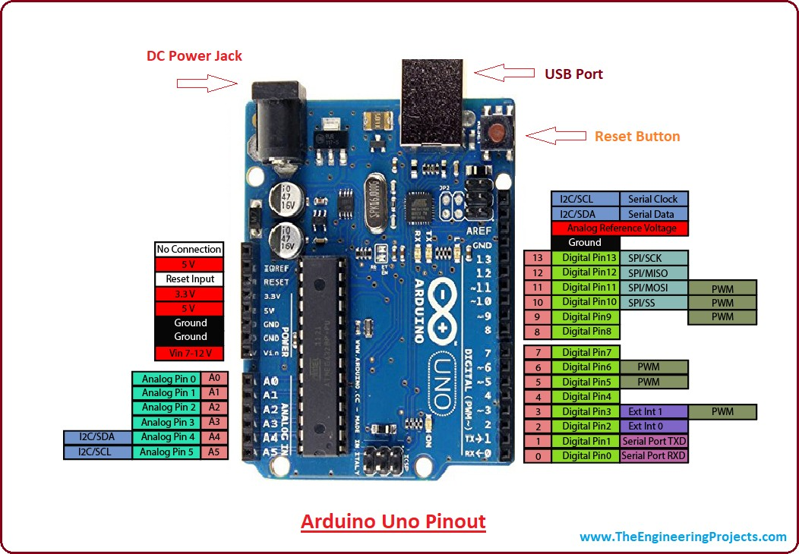

Fig: 2.2.1 Arduino UNO

### Technical specification:

* Microcontroller: Microchip ATmega328P
* Operating Voltage: 5 Volts
* Input Voltage: 7 to 20 Volts
* Digital I/O Pins: 14 (of which 6 provide PWM output)
* Analog Input Pins: 6
* DC Current per I/O Pin: 20 mA
* DC Current for 3.3V Pin: 50 mA
* Flash Memory: 32 KB of which 0.5 KB used by bootloader
* SRAM: 2 KB
* EEPROM: 1 KB
* Clock Speed: 16 MHz
* Length: 68.6 mm
* Width: 53.4 mm
* Weight: 25 g

### PIN DESCRIPTION:

|  |  |  |
| --- | --- | --- |
| **Pin category** | **Pin name** | **Details** |
| power | Vin,3.3V,5V,Gnd | Vin: Input voltage to Arduino when using an external power source.  5V: Regulated power supply used to power microcontroller and other components on the board.  3.3V: 3.3V supply generated by on-board voltage regulator. Maximum current draw is 50mA.  GND: ground pins. |
| Reset | Reset | Resets the micro controller |
| Analog pins | A0-A5 | Used to provide analog input in the range of 0-5V |
| Input Output pins | Digital pins 0-13 | Can be used as input or output pins. |
| serial | 0(RX),1(TX) | Used to receive and transmit TTL serial data. |
| External interrupts | 2,3 | To trigger an input |
| PWM | 3,5,6,9,11 | Provide 8 bit PWM output |
| SPI | 10(ss),11(MOSI),12(MISO),  13(SCK) | Used for SPI communication |
| Inbuilt LED | 13 | to turn on inbuilt LED |
| TWI | A4(SDA),A5(SCA) | Used for TWI communication |
| AREF | AREF | To provide reference voltage for input voltage |

* + 1. **TOUCH SENSOR:**

A Touch Sensor is a type of sensor that detects physical touch or proximity. They are input devices like buttons and switches but are more sensitive than those two. Hence, touch sensors are replacing buttons in devices like mobile phones and laptops. There are different types of touch sensors like resistive touch sensors, capacitive touch sensors, piezo touch sensors etc. The most common one is the capacitive type touch sensor and we have used one in this project. The advantage of touch sensors is that with a single sensor, we can get multiple operations like swipe, tap and pinch. The working of a touch sensor (Capacitive type to be specific) is simple. Basically, it detects the change in capacitance of the sensor when we touch it. Additionally, some sensors can detect these changes in capacitance without the physical contact but when the finger is placed slightly near to the sensor.

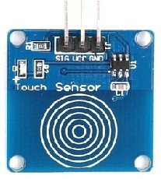

Fig: 2.2.2 Touch Sensor

**CHAPTER 3**

**Circuit Diagram:**

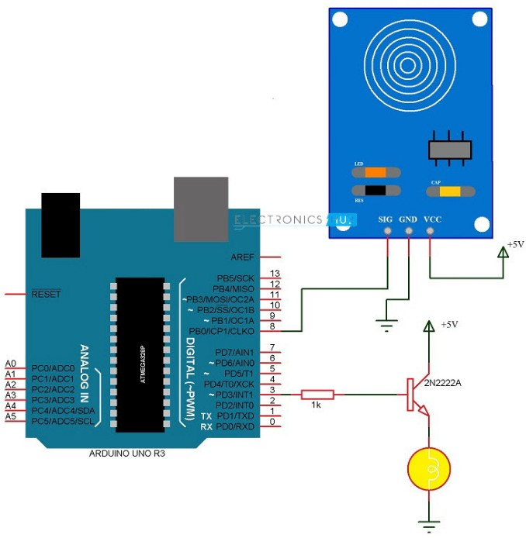

Fig: 4 Circuit Diagram

# CHAPTER 4

**CODE:**

int led = 3; int sen=8; int val=0;

void setup() { pinMode(sen,INPUT); pinMode(led,OUTPUT); digitalWrite(sen,LOW); digitalWrite(led,LOW);

}

void loop() {

while(digitalRead(sen)==LOW); while(digitalRead(sen)==HIGH)

{

while(digitalRead(sen)==HIGH)

{

if(val<=255)

{

analogWrite(led,val); val++;

delay(15);

}

}

delay(1000); while(digitalRead(sen)==HIGH)

{

if(val>=0)

{

analogWrite(led,val); val--; delay(15);

}

}

**CHAPTER 5**

**Working:**

* + - * We will connect a small incandescent bulb that glows on DC. The bulb is interface with the Arduino UNO board with the help of a transistor.
      * So, first connect the base of a transistor like 2N2222 to any digital I/O pin of Arduino UNO with the help of a current limiting resistor. Then connect the collector terminal of the transistor to the 5V power supply.
      * Finally, connect a bulb between the emitter and ground terminals. This completes the design of the circuit.
      * As mentioned earlier, there are many types of dimmer switches for different types of bulbs. In this project, a simple touch dimmer switch circuit is designed.
      * The working of the project is explained here. When the sensor is not touched, the SIG pin of the sensor remains LOW.
      * Whenever we touch the sensitive part of the touch sensor, the SIG pin of the sensor goes HIGH. Since it is connected to Arduino UNO, we will detect this change in state i.e. LOW to HIGH.
      * So, when the finger is placed on the touch sensor, Arduino UNO detects the change in the logic state of the sensor’s output and drive the bulb using Pulse Width Modulation (PWM).
      * Hence, the bulb is connected to a PWM pin of the Arduino UNO.
      * As we continue to place the finger on the touch sensor, Arduino UNO slowly increases the intensity of the bulb with the help of PWM.
      * This process continues until the finger is lifted or maximum brightness is reached i.e. the bulb is fully ON. In order to decrease the brightness of the bulb, double tap and on the double tap, continue to place the finger on the touch sensor.
      * Arduino UNO is programmed such that, if a double tap is detected (two touches with a very small delay) it has to reduce the brightness of the bulb and thus acting as a dimmer switch.
      * When continued to place the finger on the double tap the intensity of the bulb gradually decreases until the finger is lifted or the bulb reaches minimum brightness i.e. it is completely OFF

# CHAPTER 6

**OUTPUT:**

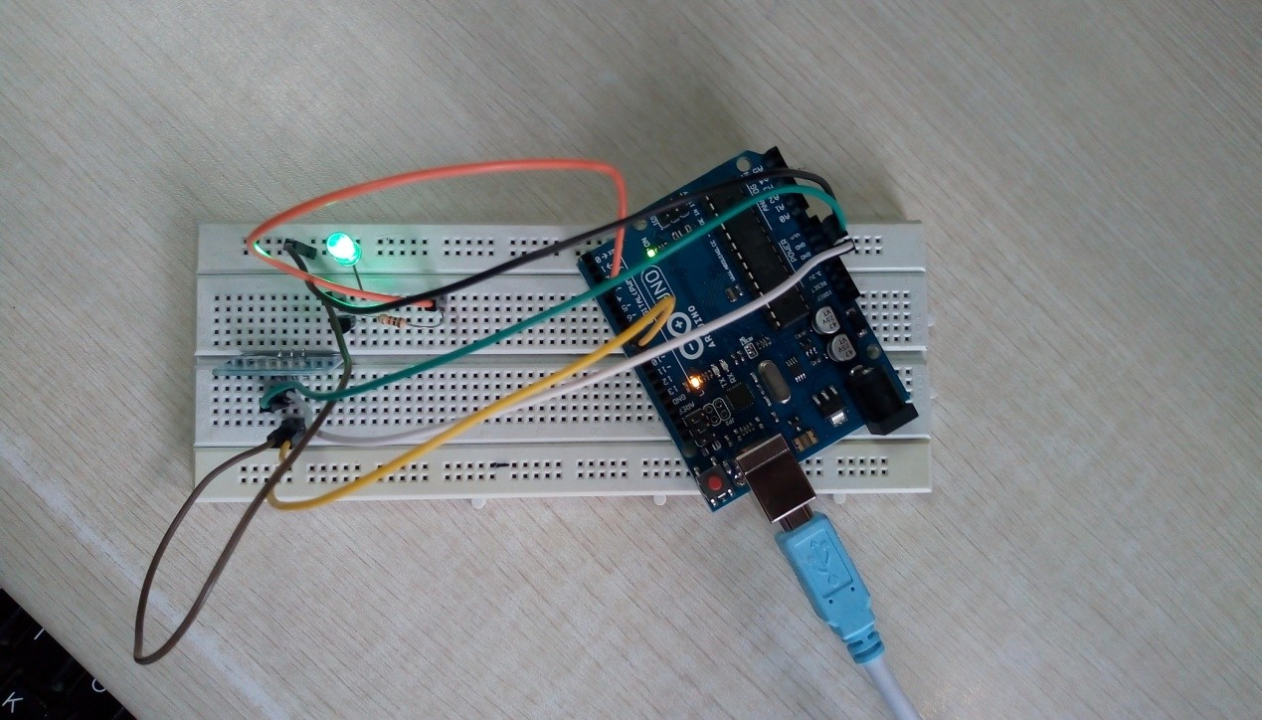

Fig: 6 Output of Touch Dimmer Switch Circuit

When the finger is placed on the touch sensor, Arduino UNO detects the change in the logic state of the sensor’s output and drive the bulb using Pulse Width Modulation (PWM). As we continue to place the finger on the touch sensor, Arduino UNO slowly increases the intensity of the bulb.

**CHAPTER 7**

**Conclusion and Future Scope:**

Mention 'touch sensors' or 'touch control' today and most people will tend to think of touchscreen displays, whether these are the cash machines (ATMs) used by banks, the selfscanning checkout terminals in grocery stores, or increasingly our smartphones, tablet computers and ereader devices. These uses certainly reflect the advances that this technology has brought to our modern life, but not every application requires this level of sophistication and more basic touch sensors still have a role to play in providing convenient, easy-to-use controls. Lighting, for the home, office or factory, is a prime example where often all that is required is the ability to turn lights on and off or apply a simple dimming function. While touch control of lighting is not new, the broader developments in touch sensing have seen a proliferation in dedicated ICs that make it even easier and more cost-effective to design touch controls for lighting.

# CHAPTER 8

**APPLICATIONS:**

* The Touch Dimmer Switch can be used to control the brightness of a bulb by simply touching the sensor.
* Can replace traditional Dimmer Switches like slide switch or rotary type switch for bulbs.
* In order to use the touch dimmer switch with AC incandescent bulbs, dedicated ICs like TT6061A can be used.

# REFERENCES:

* + https://[www.electronicshub.org/touch-dimmer-switch-circuit-using-](http://www.electronicshub.org/touch-dimmer-switch-circuit-using-) arduino/
  + https://[www.irjet.net/archives/V6/i4/IRJET-V6I4428.pdf](http://www.irjet.net/archives/V6/i4/IRJET-V6I4428.pdf)